Lab name：**OPA Adder (Summing Amplifier)** Student ID： B11102112 Name: Chiajui Lee

# Purpose

The OPA summing amplifier experiment aims to validate the fundamental principles and characteristics of operational amplifier-based adders, while developing proficiency in their design and application. This circuit utilizes the OPA's virtual ground and differential input properties to perform voltage summation, offering advantages including high input impedance, low output impedance, substantial voltage gain, and excellent common-mode rejection ratio (CMRR), making it valuable for analog circuits, digital-to-analog conversion, and signal processing applications. Through this experiment, students gain practical understanding of how the OPA's virtual ground and differential input enable precise voltage addition, enhancing their ability to implement this important analog building block in various electronic systems.

# Steps

1. Construct the specified circuit using operational amplifiers (OPAs) and resistors.
2. Connect the power supply to provide +10V to the 𝑉+ terminal and -10V to the 𝑉− terminal of the OPA.
3. Measure the output results using a multimeter.

# Data

1. Summing amplifier
   1. Circuit diagram

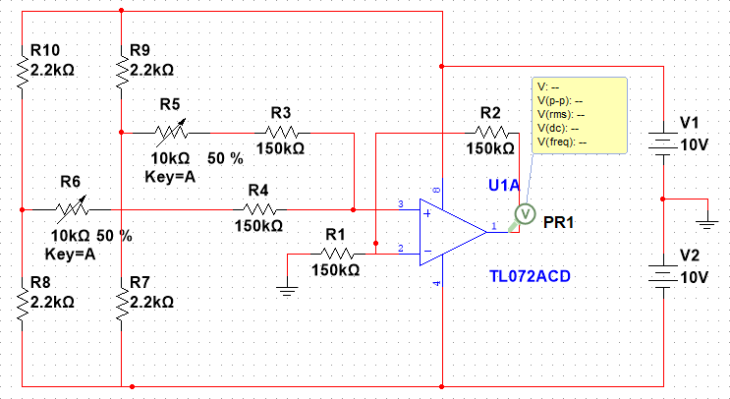

* 1. Output Value

|  |  |  |  |  |  |  |  |  |
| --- | --- | --- | --- | --- | --- | --- | --- | --- |
| **Vi1** | **-2** | **-2** | **-2** | **0** | **1** | **2** | **2** | **2** |
| **Vi2** | 2.5 | 1 | 0 | 1 | 1 | 0 | -1 | -2.5 |
| **Vo(MV)** | 0.5 | -0.99 | -2.01 | 1.05 | 2.07 | 1.96 | 0.96 | -0.55 |
| **Vo** | 0.5 | -1 | -2 | 1 | 2 | 2 | 1 | -0.5 |

* 1. Output Result

When Vi1 = 4V , Vi2 = -2.5V ; Vo = 1.5V(The meters on the right side of the following two diagrams display the output voltage.)

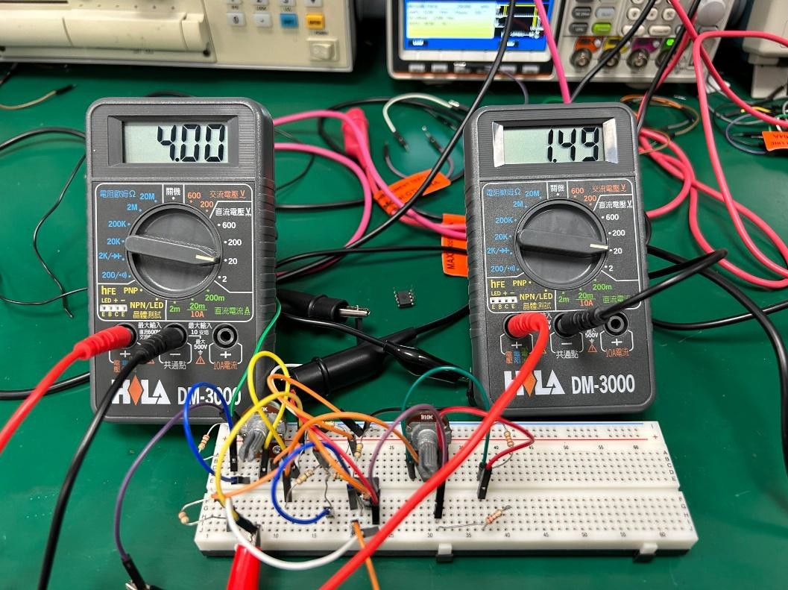

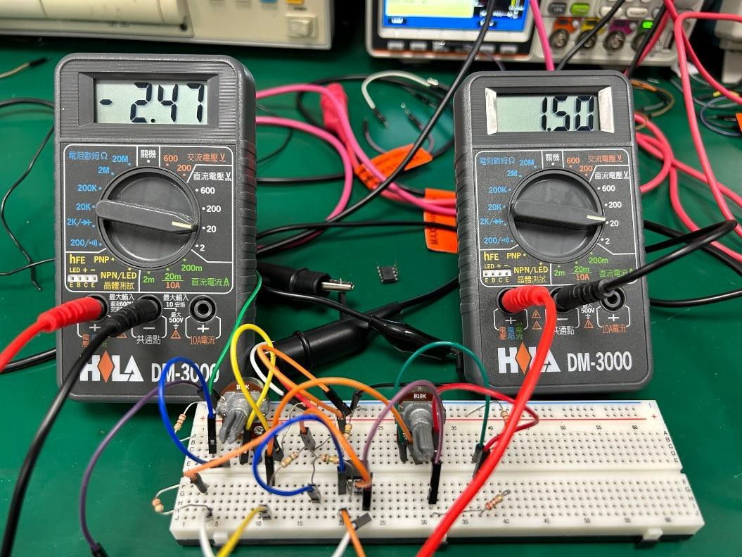

1. **Adder Application (DAC)**
2. Circuit diagram

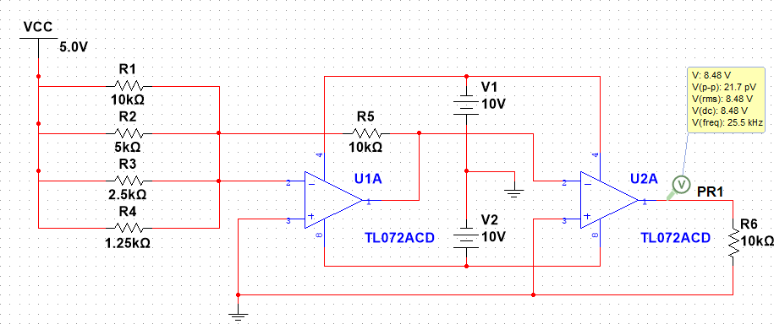

1. Output result

If R4 ON ; R1,R2,R3 OFF ; Vo = 4V

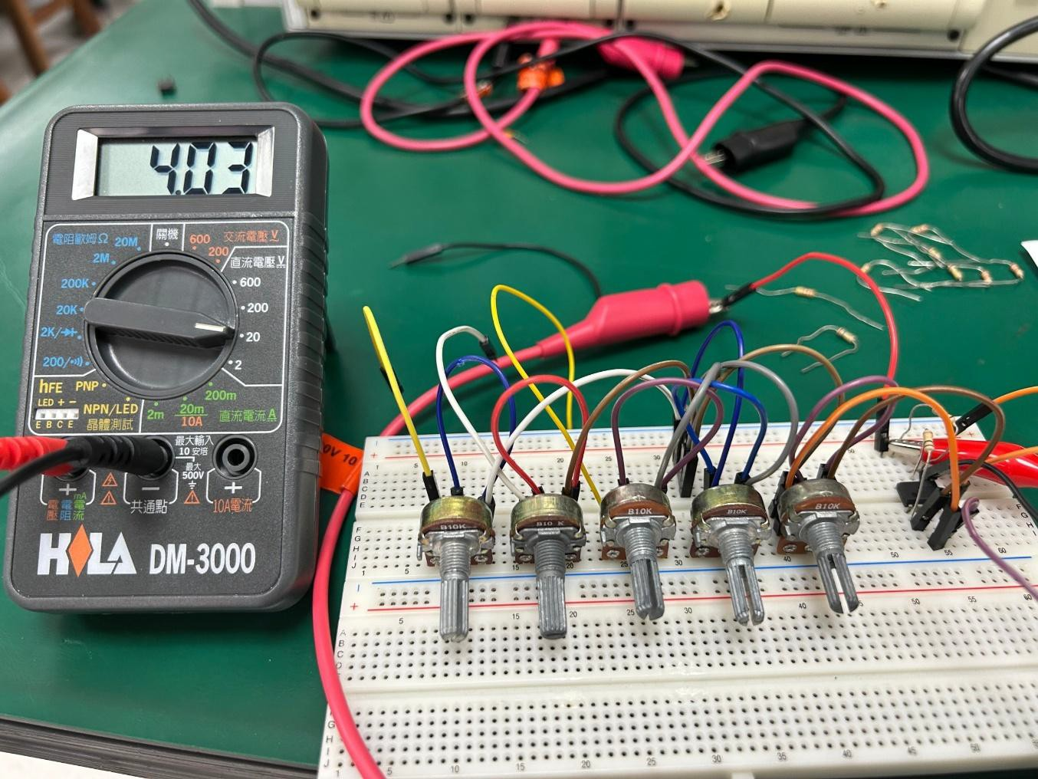

# Questions and Discussion

1. **Why does an OPA summing amplifier with variable resistors show larger output errors compared to fixed resistors?**

The output voltage of an OPA summing amplifier using **variable resistors (potentiometers)** often deviates significantly from theoretical values, while implementations with **fixed resistors** demonstrate much smaller errors. This occurs because:

1. **Nonlinear Resistance Adjustment**
   * Variable resistors exhibit nonlinear resistance changes across their rotation range, causing incorrect weighting of input voltages.
2. **Contact Resistance & Noise**
   * Wiper contact imperfections introduce unstable resistance and thermal noise, distorting the summed output.
3. **Poor Temperature Stability**
   * Most variable resistors have high temperature coefficients (±100~500ppm/°C), exacerbating drift.

# Reflections

This lab session focused on the practical implementation of an OPA summing amplifier. Initially, we encountered no major difficulties while constructing the basic summing circuit. However, during the bonus task - where resistor voltage dividers could no longer be used to supply voltages to individual summing amplifiers - we hit a roadblock.

At this impasse, I recalled a hint from our instructor about applying the principle of inverting amplifiers. This inspired me to utilize the output voltage of inverting amplifiers to amplify each summing amplifier's input voltage, thereby achieving the required functionality. Specifically, we connected the inverting amplifier's output to the summing amplifier's input and controlled the summed output by adjusting the inverting amplifier's gain.

This breakthrough allowed us to successfully overcome the technical challenge and complete the bonus task. The experience profoundly demonstrated that when facing problems, we must not only think critically but also courageously experiment with different approaches. The knowledge and insights shared by our instructor during lectures proved invaluable guidance throughout this process.